LAB ASSESSMENT 5

1)

CODE:

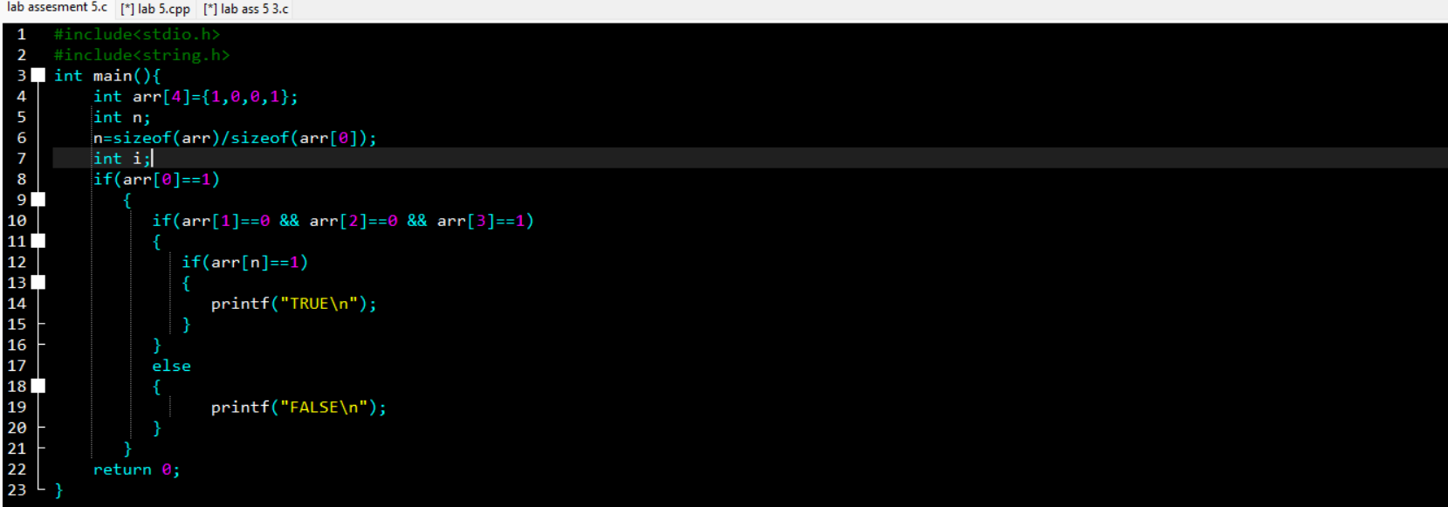

OUTPUT:

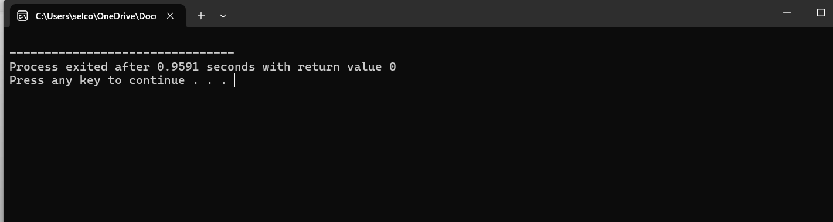

2)

CODE:

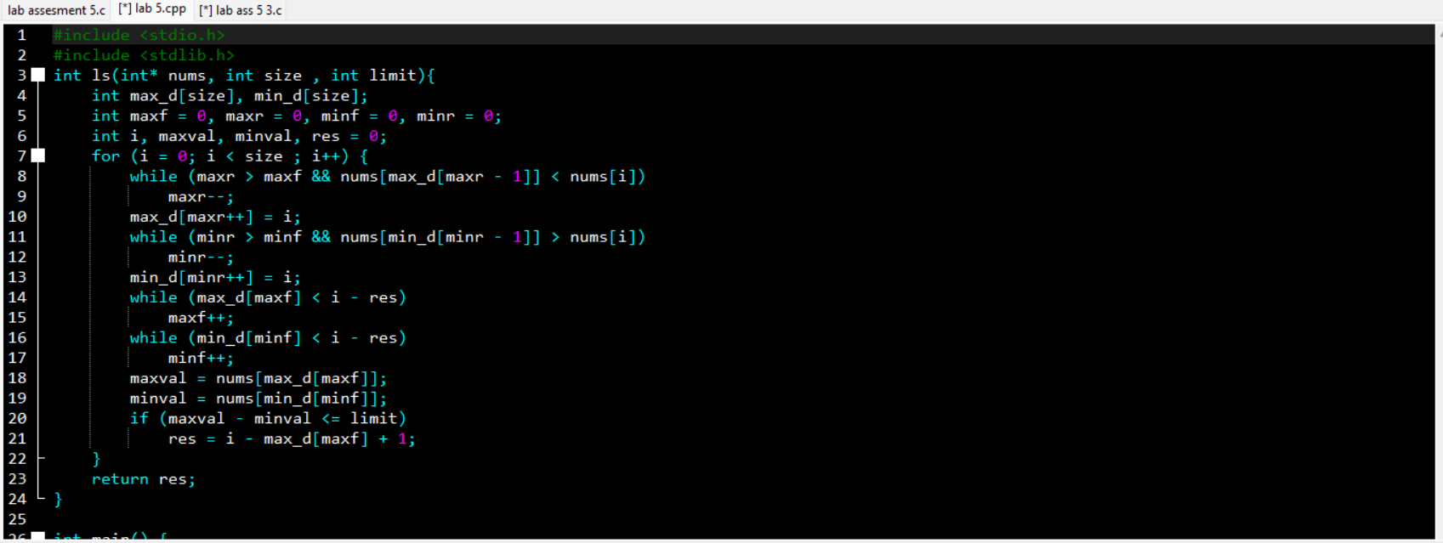

:

OUTPUT:

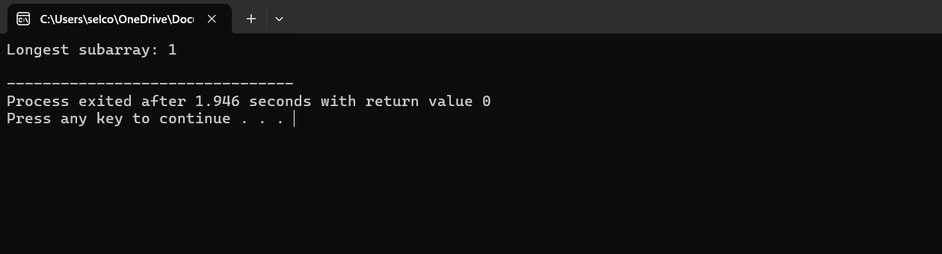

3)

CODE:

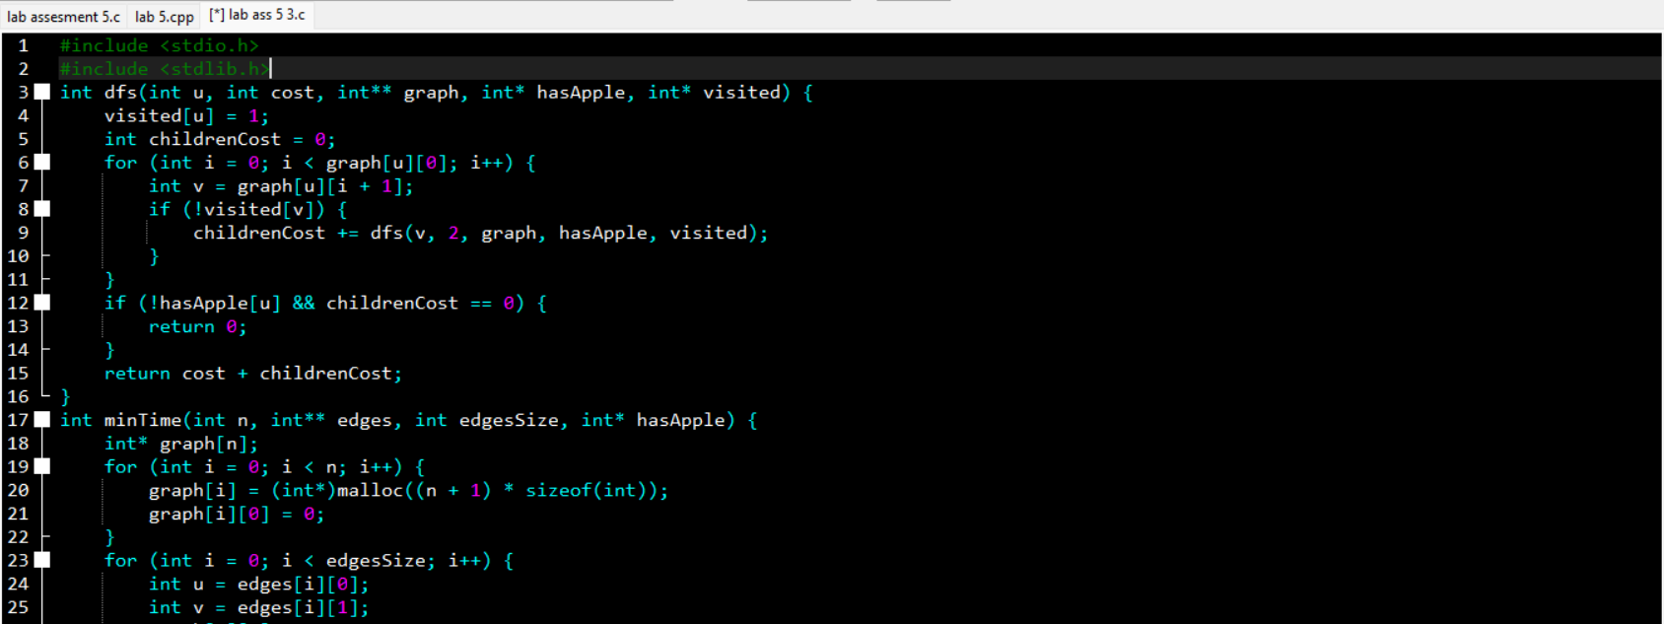

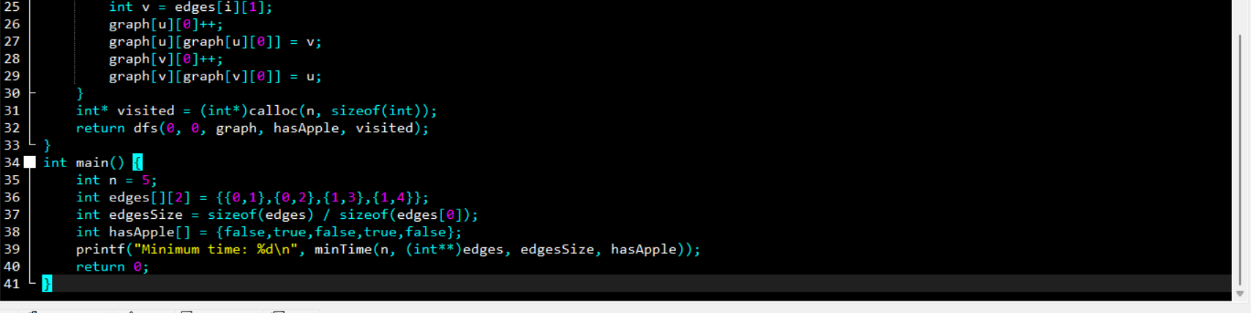

OUTPUT:

4)

CODE:

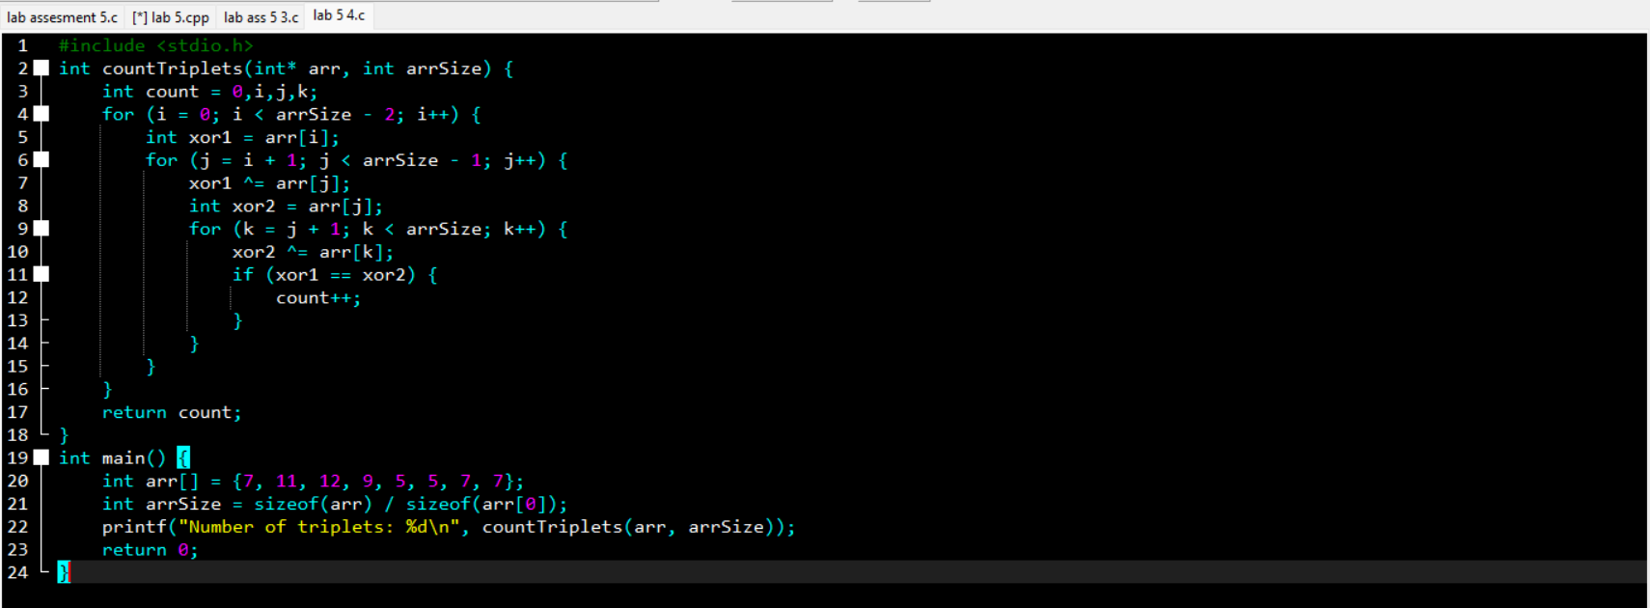

OUTPUT:

